Basic structure for most of the scientific papers
Some supplementary notes for Drug informatics, Primary resource of information
(Important to know that Technical writing module will investigate more details of everything here).

Research report (scientific paper) general structure

1. Abstract | Summarize the paper in professional way.
Introduction / Background | State of the problem.
Aim / Objectives | Purpose of the research
Method | Study design, main issues and statistical models
Results | Objective summary of the results by numbers and values
Conclusion | Your conclusion based on the research
2. Body of the paper | Document everything related to the work
1. Introduction: | Details of background, introduction
2. Literature review | Review the body of knowledge related to your current work
3. Aim and Objectives | State the detailed purpose and objectives of the work
4. Methods: | Details of study design, procedures, steps, instruments, sample related details, inclusion and exclusion criteria, ethical considerations, statistical methods, …etc
4. Results: | Detailed results: figures, tables … etc
5. Discussion: | Discuss your findings in the context of your overall work as well as previous literature and research. Clarify the limitation of the work.
6. Conclusion: | Summarise the research outcomes in clear statements.

Referencing:
Academic work is based mainly on evidences documented in previous published work (citation). When you are writing a piece of work and use someone else's words or ideas you must refer to them.
This means that you need to include detailed information on all sources, both
- within text (in-text citations)
- end of work (reference list or bibliography)

Using someone else's text without attribution is plagiarism, whether you meant to do it or not.
Plagiarism refers to using some other person's ideas and information without acknowledging that specific source.
Too many plagiarism checker software : The recommended for official institutions is ‘’Turnitin ®’’ which is not free. Other free checkers includes : •DupliChecker. •Grammarly. •Paperrater. •Plagiarisma. •Search Engine Reports. •PlagTracker.•Plagium .•CopyLeaks and may others.

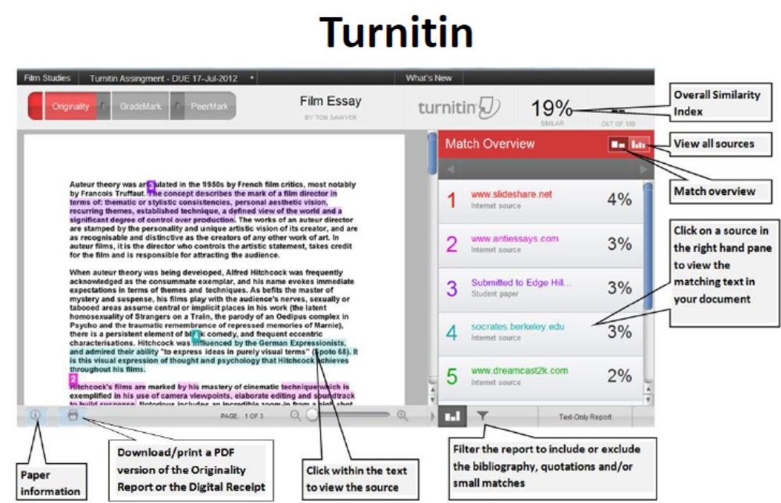

A citation style is a set of rules on how to cite your sources in academic writing.
Citation style guidelines are often published in an official handbook containing explanations, examples, and instructions. There are two main aspects that differ between styles:
•In-text citations: How you cite sources when you refer to them in the text.
•Reference list entries: How you order and format publication information for each source in the list at the end of your paper.

Too many references styles are used in academic writing, in Technical writing module we will explore more details. To summarise main concepts, styles are either Numeric based or Author based.
Citation based on numbers, Numeric styles:
(the most popular example is Vancouver style) where in-text citations and reference list are organised based on numbers.
Example: it is said the Hashemite pharmacy students at their 5th year are smart, polit and well educated⁽¹⁾ .
Reference usually as you see below.
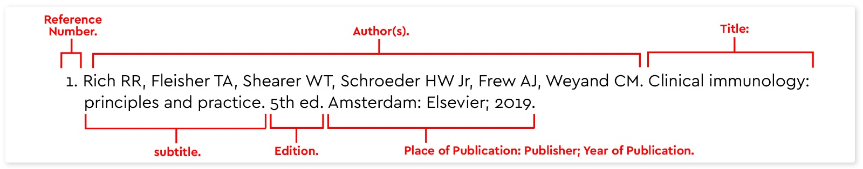
Citation based on author styles :
(the most popular example is Harvard style) where in-text citations clarify the author(s) and reference list is organised alphabetically.
Example: : it is said the Hashemite pharmacy students at their 5th year are smart, polit and well educated (Odeh, 2019).
Reference usually as you see below.

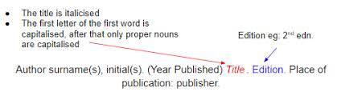

Citation style guidelines are often published in an official handbook containing explanations, examples, and instructions. Too many details are related to each referencing styles. Moreover, within the same style Citation – referencing from a book is different than citation-referencing from an article.
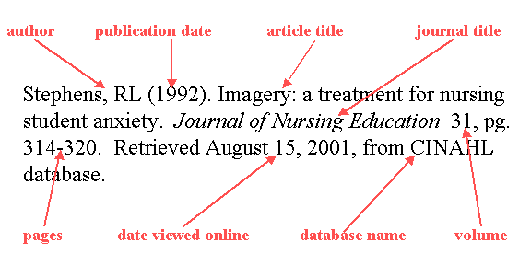
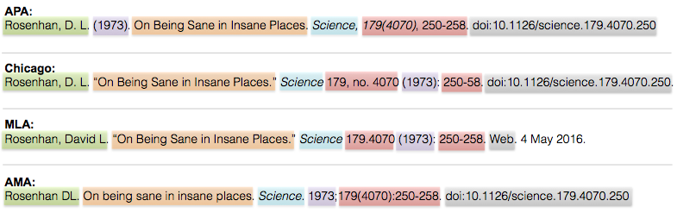

Recently, some Reference management software’s are available even for free. Examples of references software’s;
https://en.wikipedia.org/wiki/Comparison_of_reference_management_software

